HavenHub
A PROJECT REPORT

Submitted by

Sata Mihir Hiren
Patel Laxit Hareshkumar
Patel Maan RohitBhai
Patel Rishi Vinodchandra
In fulfillment for the award of the degree
of
BACHELOR OF ENGINEERING
in
Computer Engineering



LDRP Institute of Technology and Research, Gandhinagar
Kadi Sarva Vishwavidyalaya
January,2025
LDRP Institute of Technology and Research
Gandhinagar

CE-IT Department
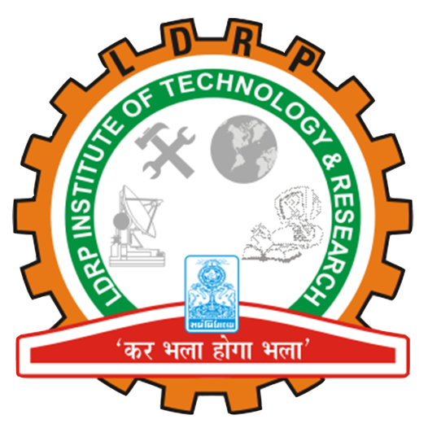

CERTIFICATE
This is to certify that the Project Work entitled “HavenHub” has been carried out by Sata Mihir Hiren (#22BECE30414) under my guidance in fulfilment of the degree of Bachelor of Engineering in Computer Engineering Semester-6 of Kadi Sarva Vishwavidyalaya University during the academic year 2024-2025.

Prof.Rajul Suthar Dr.AshishKumar Patel
Internal Guide Head of the Department
LDRP ITR LDRP ITR

LDRP Institute of Technology and Research
Gandhinagar

CE-IT Department

CERTIFICATE
This is to certify that the Project Work entitled “HavenHub” has been carried out by Patel Laxit HareshKumar (#22BECE30296) under my guidance in fulfilment of the degree of Bachelor of Engineering in Computer Engineering Semester-6 of Kadi Sarva Vishwavidyalaya University during the academic year 2024-2025.

Prof.Rajul Suthar Dr.AshishKumar Patel
Internal Guide Head of the Department
LDRP ITR LDRP ITR

LDRP Institute of Technology and Research
Gandhinagar

CE-IT Department

CERTIFICATE
This is to certify that the Project Work entitled “HavenHub” has been carried out by Patel Maan Rohitbhai (#22BECE30297) under my guidance in fulfilment of the degree of Bachelor of Engineering in Computer Engineering Semester-6 of Kadi Sarva Vishwavidyalaya University during the academic year 2024-2025.

Prof.Rajul Suthar Dr.AshishKumar Patel
Internal Guide Head of the Department
LDRP ITR LDRP ITR

LDRP Institute of Technology and Research
Gandhinagar

CE-IT Department

CERTIFICATE
This is to certify that the Project Work entitled “HavenHub” has been carried out by Patel Rishi Vinodchandra (#22BECE30332) under my guidance in fulfilment of the degree of Bachelor of Engineering in Computer Engineering Semester-6 of Kadi Sarva Vishwavidyalaya University during the academic year 2024-2025.

Prof.Rajul Suthar Dr.AshishKumar Patel
Internal Guide Head of the Department
LDRP ITR LDRP ITR

Presentation-I for Project-I
1. Name & Signature of Internal Guide
2. Comments from Panel Members
3. Name & Signature of Panel Members

